Media Unsubscribe screens
Screen 1: Dashboard
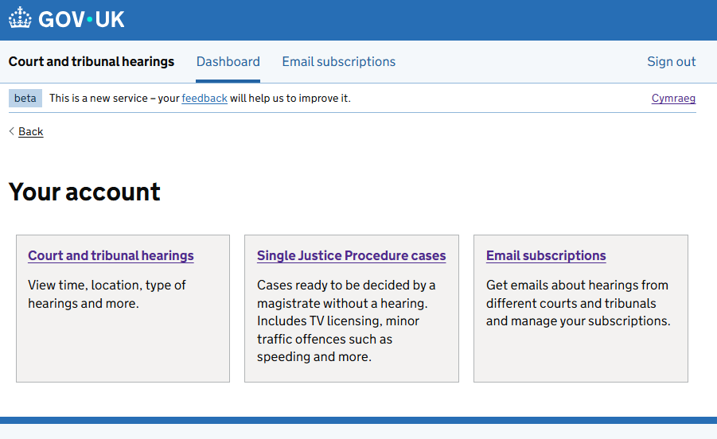

Screen 2: Your email subscriptions
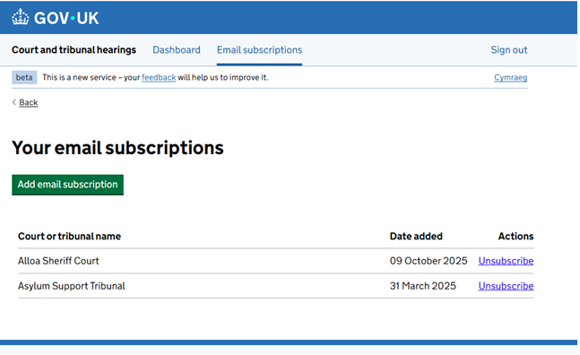
Screen 3: Unsubscribe / Are you sure you want to remove this subscription?
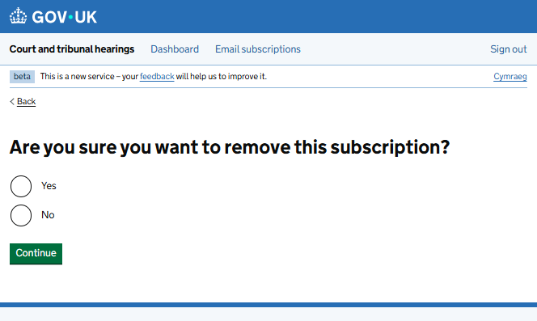

Screen 4: Subscriptions removed
